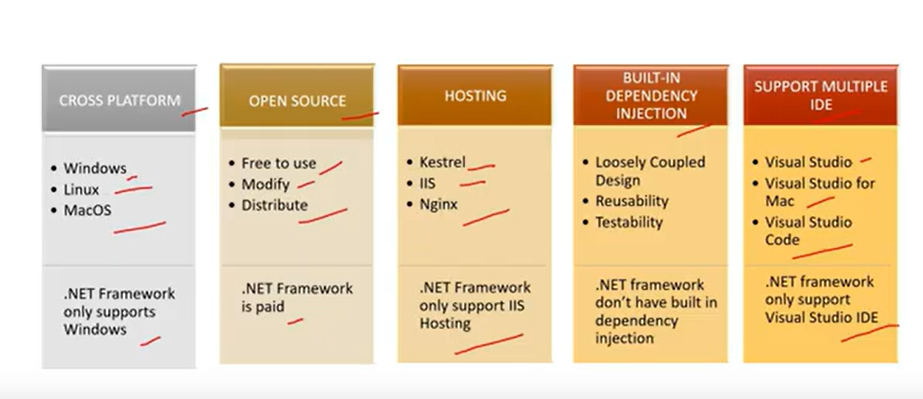

Step 1: Install Visual Studio 2022 (if not installed)
- Download and install Visual Studio 2022 from Microsoft's website.
- During installation, select ASP.NET and web development workload.

Step 2: Create a New ASP.NET Core MVC Project
- Open Visual Studio 2022.
- Click on "Create a new project".
- Search for "ASP.NET Core Web App (Model-View-Controller)" and select it.
- Click Next.
- Give your project a name (e.g., OrganizationRegistration).
- Choose a location for the project.
- Click Next.
- Choose:
  - .NET 6.0 (LTS) or later.
  - Keep Authentication Type: None (we will add later).
  - Click Create.

Step 3: Create the Registration Form

1. Create a Model (Registration.cs)
- In Solution Explorer, right-click on the Models folder → Click Add → Class.
- Name it Registration.cs and add the following code:
using System.ComponentModel.DataAnnotations;

namespace OrganizationRegistration.Models
{
public class Registration
{
[Key]
public int Id { get; set; }

[Required(ErrorMessage = "Full Name is required")]
public string FullName { get; set; }

[Required(ErrorMessage = "Email is required")]
[EmailAddress]
public string Email { get; set; }

[Required(ErrorMessage = "Phone Number is required")]
public string PhoneNumber { get; set; }

[Required(ErrorMessage = "Department is required")]
public string Department { get; set; }

[Required(ErrorMessage = "Password is required")]
[DataType(DataType.Password)]
public string Password { get; set; }

[Compare("Password", ErrorMessage = "Passwords do not match")]
[DataType(DataType.Password)]
public string ConfirmPassword { get; set; }
}
}

2. Create a Database Context
- In Solution Explorer, right-click on Models → Add → Class.
- Name it ApplicationDbContext.cs and add:
using Microsoft.EntityFrameworkCore;

namespace OrganizationRegistration.Models
{
public class ApplicationDbContext : DbContext
{
public ApplicationDbContext(DbContextOptions<ApplicationDbContext> options) : base(options) { }

public DbSet<Registration> Registrations { get; set; }
}
}

Step 4: Configure Database (SQL Server)
- Open appsettings.json and modify the connection string:
"ConnectionStrings": {
"DefaultConnection": "Server=(localdb)\\mssqllocaldb;Database=OrganizationDB;Trusted_Connection=True;MultipleActiveResultSets=true"
}

- Open Program.cs (or Startup.cs in older versions) and add:
using Microsoft.EntityFrameworkCore;
using OrganizationRegistration.Models;

var builder = WebApplication.CreateBuilder(args);

// Add services to the container.
builder.Services.AddControllersWithViews();

// Add Database Context
builder.Services.AddDbContext<ApplicationDbContext>(options =>
options.UseSqlServer(builder.Configuration.GetConnectionString("DefaultConnection")));

var app = builder.Build();

app.UseStaticFiles();
app.UseRouting();
app.UseAuthorization();
app.MapControllers();

app.Run();

Step 5: Add Migrations & Update Database
- Open Tools → NuGet Package Manager → Manage NuGet Packages for Solution.
- Install:
  - Microsoft.EntityFrameworkCore.SqlServer
  - Microsoft.EntityFrameworkCore.Tools
- Open Package Manager Console (View > Other Windows > Package Manager Console).
- Run the commands:
Add-Migration InitialCreate
Update-Database

Step 6: Create the Controller
- In Solution Explorer, right-click on the Controllers folder → Add → Controller.
- Select MVC Controller with views, using Entity Framework.
- Choose the Registration Model and ApplicationDbContext.
- Click Add.
This automatically creates a RegistrationController.cs file.

Step 7: Modify Registration View
- Open Views/Registration/Create.cshtml.
- Modify the form to include advanced controls:

@model OrganizationRegistration.Models.Registration

<h2>Registration Form</h2>

<form asp-action="Create">
<div class="form-group">
<label asp-for="FullName" class="control-label"></label>
<input asp-for="FullName" class="form-control" />
<span asp-validation-for="FullName" class="text-danger"></span>
</div>

<div class="form-group">
<label asp-for="Email" class="control-label"></label>
<input asp-for="Email" type="email" class="form-control" />
<span asp-validation-for="Email" class="text-danger"></span>
</div>

<div class="form-group">
<label asp-for="PhoneNumber" class="control-label"></label>
<input asp-for="PhoneNumber" type="tel" class="form-control" />
<span asp-validation-for="PhoneNumber" class="text-danger"></span>
</div>

<div class="form-group">
<label asp-for="Department" class="control-label"></label>
<select asp-for="Department" class="form-control">
<option value="">Select Department</option>
<option value="IT">IT</option>
<option value="HR">HR</option>
<option value="Finance">Finance</option>
</select>
<span asp-validation-for="Department" class="text-danger"></span>
</div>

<div class="form-group">
<label asp-for="Password" class="control-label"></label>
<input asp-for="Password" type="password" class="form-control" />
<span asp-validation-for="Password" class="text-danger"></span>
</div>

<div class="form-group">
<label asp-for="ConfirmPassword" class="control-label"></label>
<input asp-for="ConfirmPassword" type="password" class="form-control" />
<span asp-validation-for="ConfirmPassword" class="text-danger"></span>
</div>

<br>
<button type="submit" class="btn btn-primary">Register</button>
</form>

Step 8: Enable Client-Side Validation
- Open _Layout.cshtml.
- Add the following inside <head>:

<script src="https://cdnjs.cloudflare.com/ajax/libs/jquery/3.6.0/jquery.min.js"></script>
<script src="https://cdnjs.cloudflare.com/ajax/libs/jquery-validate/1.19.3/jquery.validate.min.js"></script>
<script src="https://cdnjs.cloudflare.com/ajax/libs/jquery-validation-unobtrusive/3.2.11/jquery.validate.unobtrusive.min.js"></script>

Step 9: Run the Application
- Click Start (IIS Express).
- Navigate to /Registration/Create to fill out the form.

